|  |  |
| --- | --- |
| Day 1 - Java Programming Basics | Pg 1 |
| Day 2 - OOP Concepts, etc | Pg 3 |
| Day 3 - Selenium Basics | Pg 9 |
| Day 4 - Selenium continued | Pg 14 |
| Day 5 - Test Case -login page validation | Pg 19 |

**DAY 1:**

* Classes example: students, teachers, desk, boards, projector
* Class: variables, methods, objects
* Variable: to store elements throughout the execution of the program
* function/methods: write a statement which can be used multiple times

Example: Why class is used: WhatsApp

|  |  |
| --- | --- |
| Feature | Person assigned to develop it |
| Calling | John |
| Messaging | Tracy |
| Status | Jason |
| Payment | Diana |
| Profile | Mike |

Functions:

class Call  
{  
public void voiceCall() { }  
public void videoCall() { }  
}  
class Message  
{  
public void textMessage() { }  
public void voiceNotes() { }  
public void attachments() { }  
}  
Class WhatsApp  
{  
public static void main(String[] args)  
{  
Calls c=new Calls();  
Message m= new Message();  
c.voiceCalls();  
c.videoCalls();  
}  
}

Simple Java Program and variables:

public class SimpleJavaProgram  
{  
 public static void main(String[] args)*//entry point*  
 {  
 System.out.println("Hello World!");  
 }  
}

public class SimpleJavaProgram  
{  
 public static void main(String[] args)*//entry point*  
 {  
 int num=10;  
 float dec1=12.5f;  
 float dec1=12.5353546;  
 char alpha='a';  
 String data="We are learning Java";  
   
 System.out.println("Number is: "+num);  
 System.out.println("Decimal 1 is: "+dec1+"\n Decimal 2 is: "+dec2  
 +"\n Character is: "+alpha+"\n String is: "+data+);  
 }  
}

Conditional Statements & loops: simple if, simple if-else, nested if-else, multiple if-else

public class ConditionalLoopsStatement  
{  
 public static void main(String[] args)*//entry point*  
 {  
 int time=11;  
 if(time==2)  
 {  
 System.out.println("Selenium training is starting");  
 }  
 else  
 {  
 System.out.println("No training currently");  
 }  
 }  
}

Loops: pre-tested loop(while,for), post-tested loop(do-while)

public class ConditionalLoopsStatement

{  
 public static void main(String[] args)*//entry point*  
 {  
 for(int i=1;i<=10;i++)  
 {  
 System.out.println(i+". Selenium");  
 }  
 }  
}

Eclipse IDE screenshot:

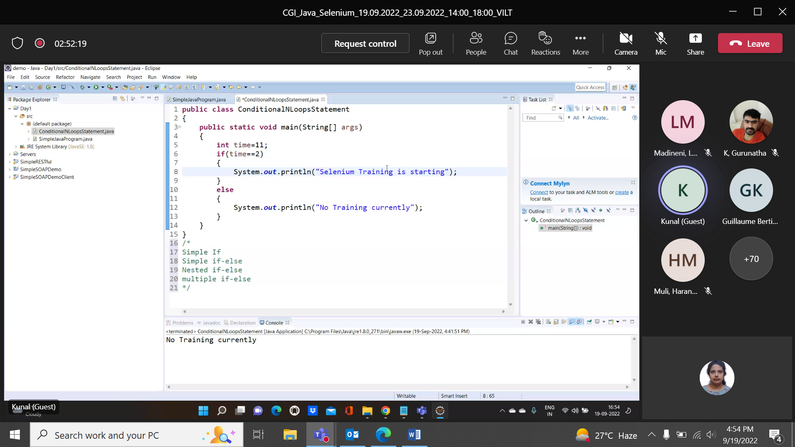

**DAY 2:**

Static initialization of variables in method initEmployee(), class & method variables:

public class EmployeeMgmtSysMain  
{  
 public static void main(String[] args)*//entry point*  
 {  
 Employee emp=new Employee();  
 emp.initEmployee();  
 emp.dispEmployee();  
 }  
}  
  
public class Employee  
{  
 private int empid;  
 private String name;  
 private double salary;  
 public void initEmployee()  
 {  
 empid=101;  
 name="John";  
 salary=250000.0;  
 }  
   
 public void dispEmployee()  
 {  
 System.out.println("Employee id: "+empid);  
 System.out.println("Employee id: "+empid+"\n Name: "+name  
 +"\n Salary: "+salary);  
 }  
}

Using Constructor:

public class EmployeeMgmtSysMain  
{  
 public static void main(String[] args)*//entry point*  
 {  
 Employee emp=new Employee();  
 emp.dispEmployee();  
 System.out.println();  
 Employee emp2=new Employee(102,"Victor",3500000.0);  
 emp2.dispEmployee();  
 }  
}  
  
public class Employee  
{  
 private int empid;  
 private String name;  
 private double salary;  
   
 public Employee()  
 {  
 empid=101;  
 name="John";  
 salary=250000.0;   
 }  
   
 public Employee(int e,String n,double s)  
 {  
 empid=e;  
 name=n;  
 salary=s;  
 }  
   
 public void dispEmployee()  
 {  
 System.out.println("Employee id: "+empid);  
 System.out.println("Employee id: "+empid+"\n Name: "+name  
 +"\n Salary: "+salary);  
 }  
}

this keyword:

public class EmployeeMgmtSysMain  
{  
 public static void main(String[] args)*//entry point*  
 {  
 Employee emp2=new Employee(102,"Victor",3500000.0);  
 emp2.dispEmployee();  
 }  
}  
  
public class Employee  
{  
 private int empid;  
 private String name;  
 private double salary;  
   
 public Employee()  
 {  
 System.out.println("Default Constructor");   
 }  
   
 public Employee(int empid,String name,double salary)  
 {  
 this();  
 this.empid=empid;  
 this.name=name;  
 this.salary=salary;  
 System.out.println("Parameterized Constructor");  
 this.dispEmployee()  
 }  
   
 public void dispEmployee()  
 {  
 System.out.println("Employee id: "+empid);  
 System.out.println("Employee id: "+empid+"\n Name: "+name  
 +"\n Salary: "+salary);  
 }  
}

Getter and setter methods:

public class EmployeeMgmtSysMain  
{  
 public static void main(String[] args)*//entry point*  
 {  
 Employee emp2=new Employee(102,"Victor",3500000.0);  
 emp2.dispEmployee();  
 emp2.setSalary(400000.0);  
 System.out.println("Salary is changed to: "+emp2.getSalary);  
 emp2.dispEmployee();  
 }  
}  
  
public class Employee  
{  
 private int empid;  
 private String name;  
 private double salary;  
   
 public Employee(int empid,String name,double salary)  
 {  
 this.empid=empid;  
 this.name=name;  
 this.salary=salary;  
 }  
   
 public void dispEmployee()  
 {  
 System.out.println("Employee id: "+empid);  
 System.out.println("Employee id: "+empid+"\n Name: "+name  
 +"\n Salary: "+salary);  
 }  
 public int getEmpid()  
 {  
 return empid;  
 }  
 public void setEmpid(int empid)  
 {  
 this.empid=empid;  
 }  
 public String getname()  
 {  
 return name;  
 }  
 public void setEmpname(String name)  
 {  
 this.name=name;  
 }  
 public double getSalary()  
 {  
 return salary;  
 }  
 public void setSalary(double salary)  
 {  
 this.salary=salary;  
 }  
}

Inheritance: Deriving the property from base class to derived class

public class EmployeeMgmtSysMain  
{  
 public static void main(String[] args)*//entry point*  
 {  
 Manager man=new Manager();  
 man.dispEmployee();  
 man.dispBonus();  
 }  
}  
  
public class Employee  
{  
 private int empid;  
 private String name;  
 private double salary;  
   
 public Employee()  
 {  
 empid=101;  
 name="John";  
 salary=2500000.0;  
 }  
   
 public void dispEmployee()  
 {  
 System.out.println("Employee id: "+empid);  
 System.out.println("Employee id: "+empid+"\n Name: "+name  
 +"\n Salary: "+salary);  
 }   
}  
public class Manager extends Employee  
{  
 private double bonus;  
 public Manager()  
 {  
 bonus=5000.0;  
 }  
 public void dispBonus("Bonus: "+bonus);  
}

Polymorphism: Many forms

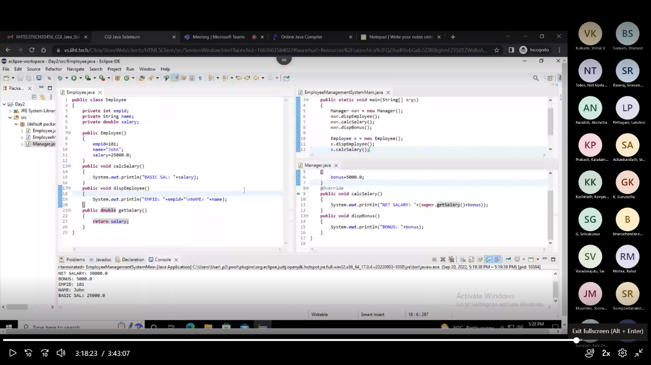

Exception:

* Any error which is occurred during the execution of the program is called runtime error or exception
* To avoid abnormal termination of the program, it is necessary to handle the exception
* In Java, to handle any runtime error, we use a mechanism called try, catch
* Try block contains the code which may have exception. It executes the code assuming there is no exception, if any exception has occurred then it will send it to catch block
* Catch block is used to handle the exception from try block. It has a parameter of exception type class

public class ExceptionDemo  
{  
 public static void main(String[] args)*//entry point*  
 {  
 System.out.println("Start");  
 int a=10,b=2,c;  
 try  
 {  
 c=a/b;  
 System.out.println("Division "+c);  
 }  
 catch(ArithmeticException ex)  
 {  
 System.out.println("Exception: "+ex);  
 }  
 System.out.println("Stop");  
 }  
}

**DAY 3:**

In Citrix Virtual Desktop install Google Chrome browser, EclipseIDE and selenium webdriver for chrome

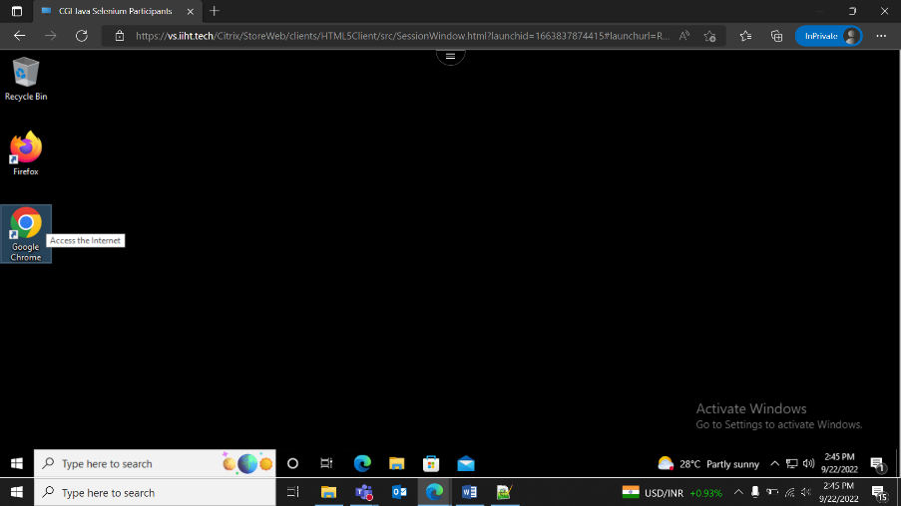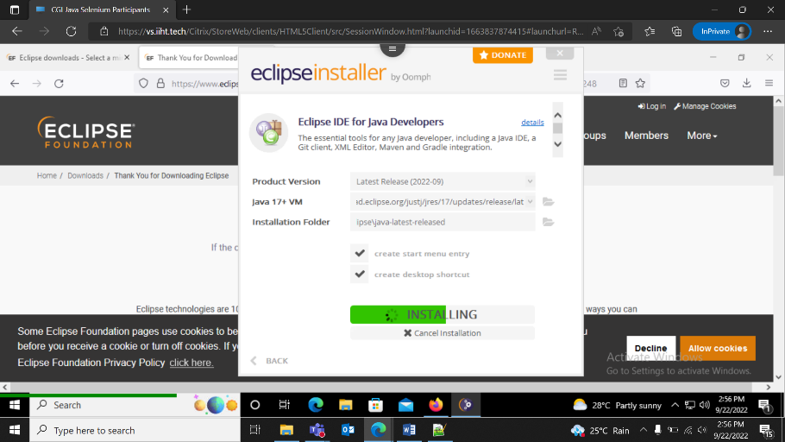

Example Login testing

[www.saucedemo.com](http://www.saucedemo.com)

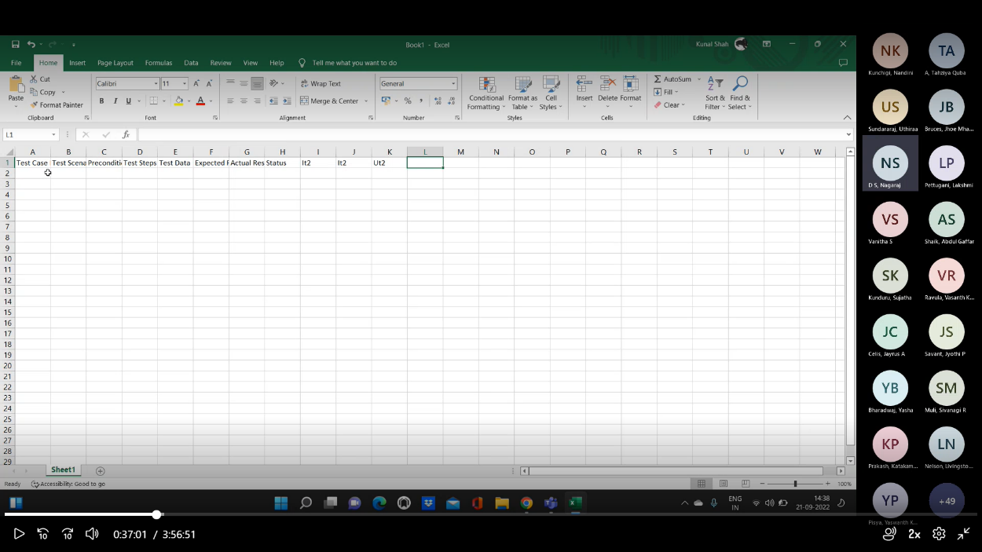

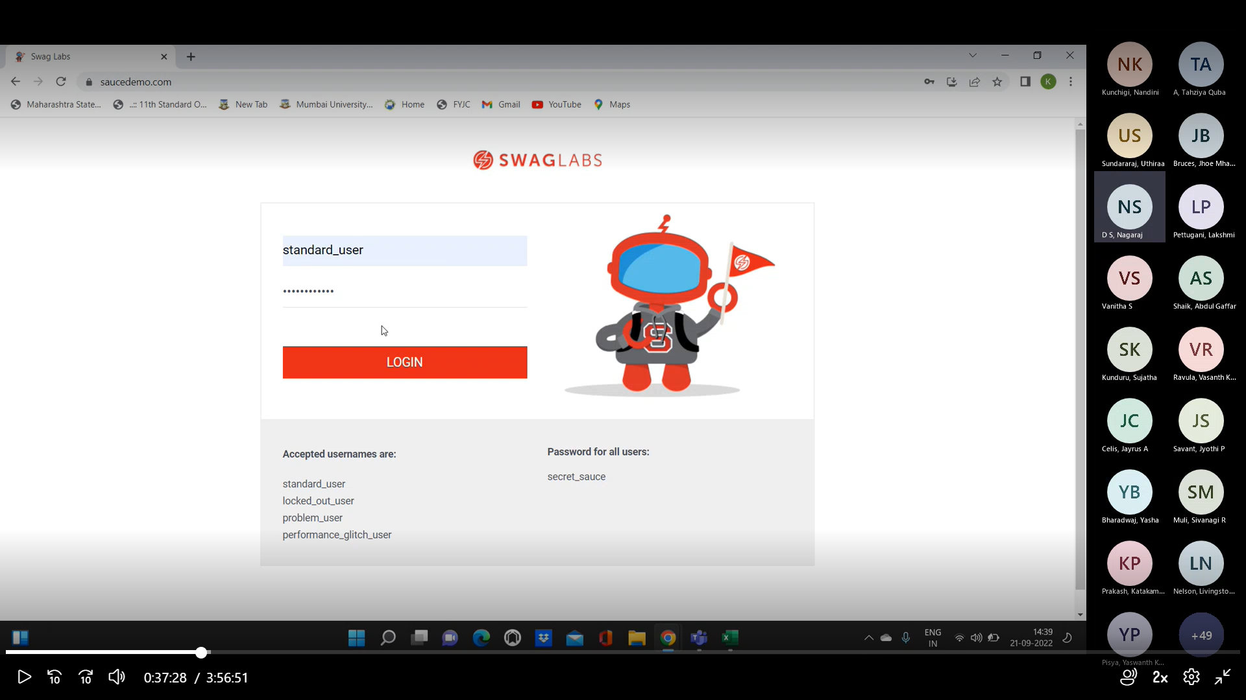

Copy maven dependency from www.mvnrepository.com (Selenium->Selenium Java 3.7) and add to pom.xml

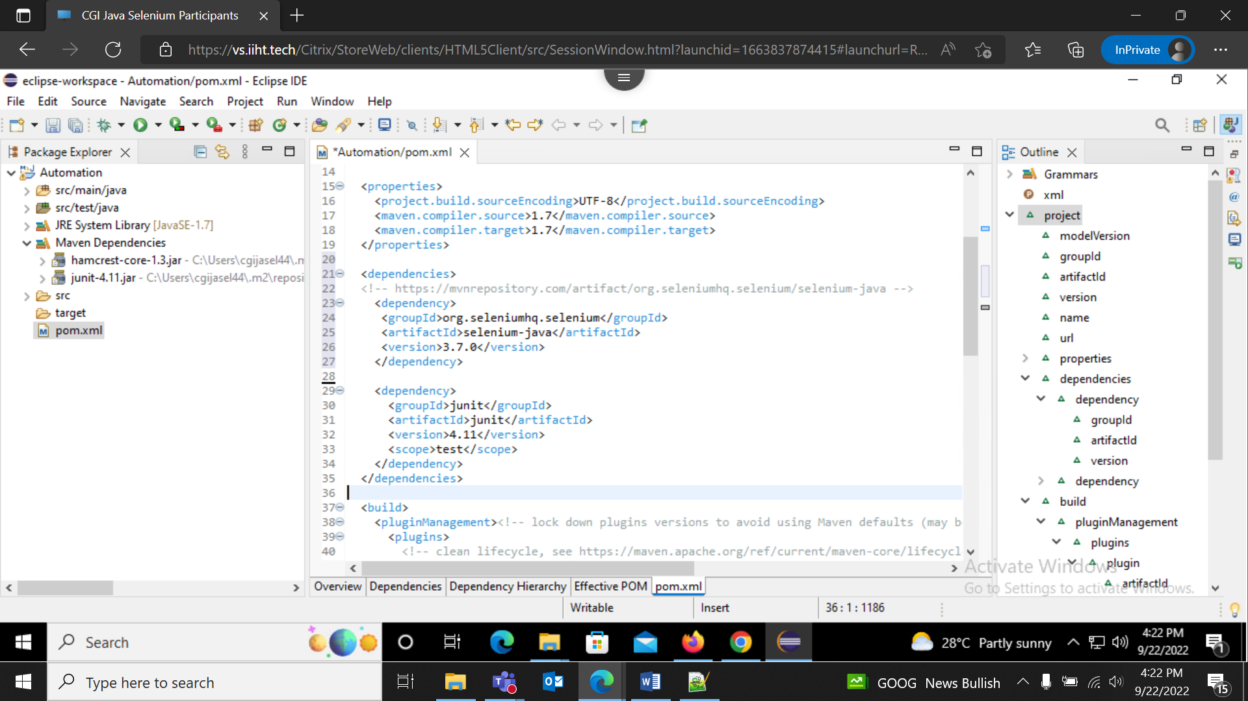

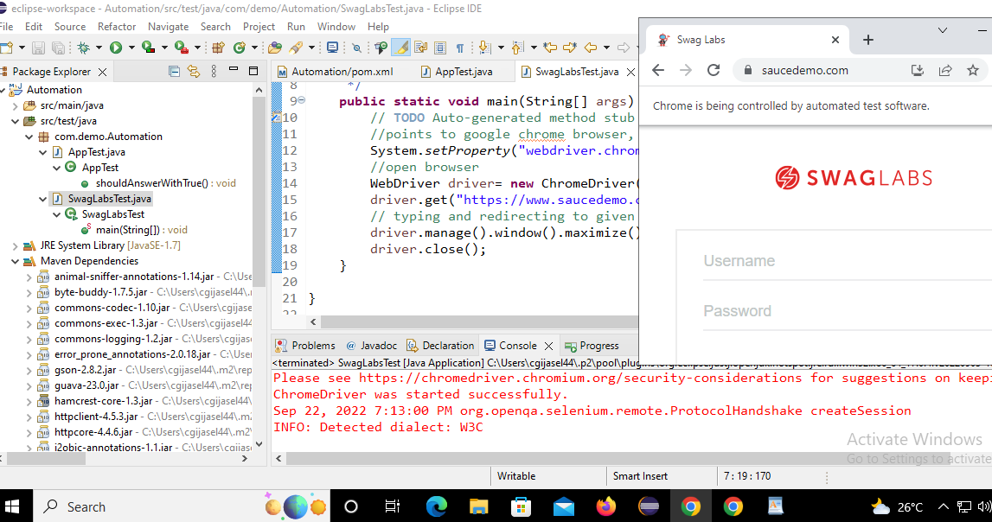

package com.demo.Automation;  
import org.openqa.selenium.WebDriver;  
import org.openqa.selenium.chrome.ChromeDriver;  
public class SwagLabsTest {  
   
 */\*\**  
  *\* @param args*  
  *\*/*  
 public static void main(String[] args) {  
 *// TODO Auto-generated method stub*  
 *//points to google chrome browser, add chrome driver*  
 System.setProperty("webdriver.chrome.driver","C:\\Users\\cgijasel44\\Desktop\\chromedriver.exe");  
 *//open browser*  
 WebDriver driver= new ChromeDriver();  
 driver.get("https://www.saucedemo.com/");  
 *// typing and redirecting to given url*  
 driver.manage().window().maximize();  
 *//found the element*  
 WebElement username=driver.findElement(By.id(“user-name”));  
 WebElement password=driver.findElement(By.id(“password”));  
 WebElement loginbtn=driver.findElement(By.id(“login-button”));  
*//or driver.findElement(By.id(“user-name”)).sendKeys(“standard_user”);*   
username.sendKeys(“standard_user”);  
password.sendKeys(“secret_sauce”);

loginbtn.click();  
Thread.sleep(2000);*//wait 2 seconds i.e. synchronization wait*  
driver.findElement(By.linkText(“Sauce Labs Backpack”)).click();  
Thread.sleep(2000);  
*//driver.findElement(By.xpath(“/html/body/div/div/div/div[2]/div/div/div[2]/button”)).click();*  
Thread.sleep(3000);  
driver.findElement(By.xpath(“*//button[@id=”add-to-cart-sauce-labs-backpack”]”)).click();*  
driver.manager.timeouts().implicitlywait(5,TimeUnit.SECONDS);  
driver.close();  
 }  
   
}

LinkText screenshot reference:

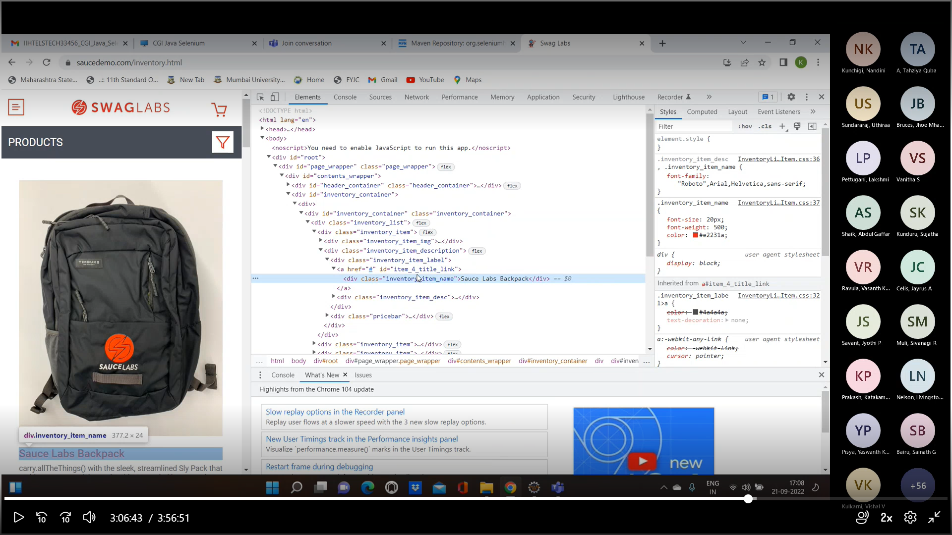

Copy Xpath screenshot reference:

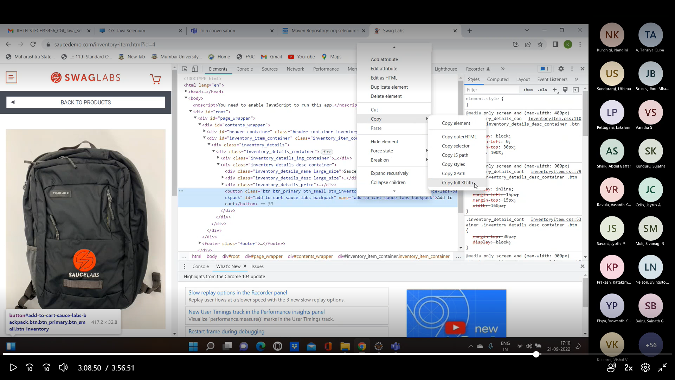

Writing own xpath:

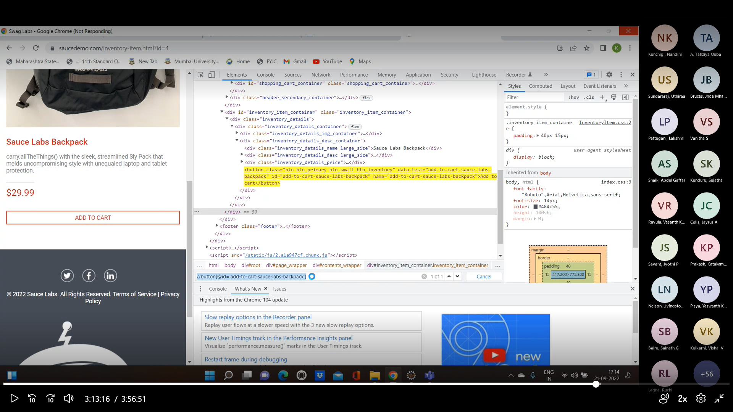

**DAY 4:**

Mouse movement and click dropdown menu:

WebElement dropdown= driver.findElement(By.className("bm-icon"));  
WebElement dropdown= driver.findElement(By.className("bm-icon"));  
Actions actions=new Actions(driver);  
Action mousemovement=actions.moveToElement(dropdown).click().build();  
mousemovement.perform();  
Thread.sleep(3000);

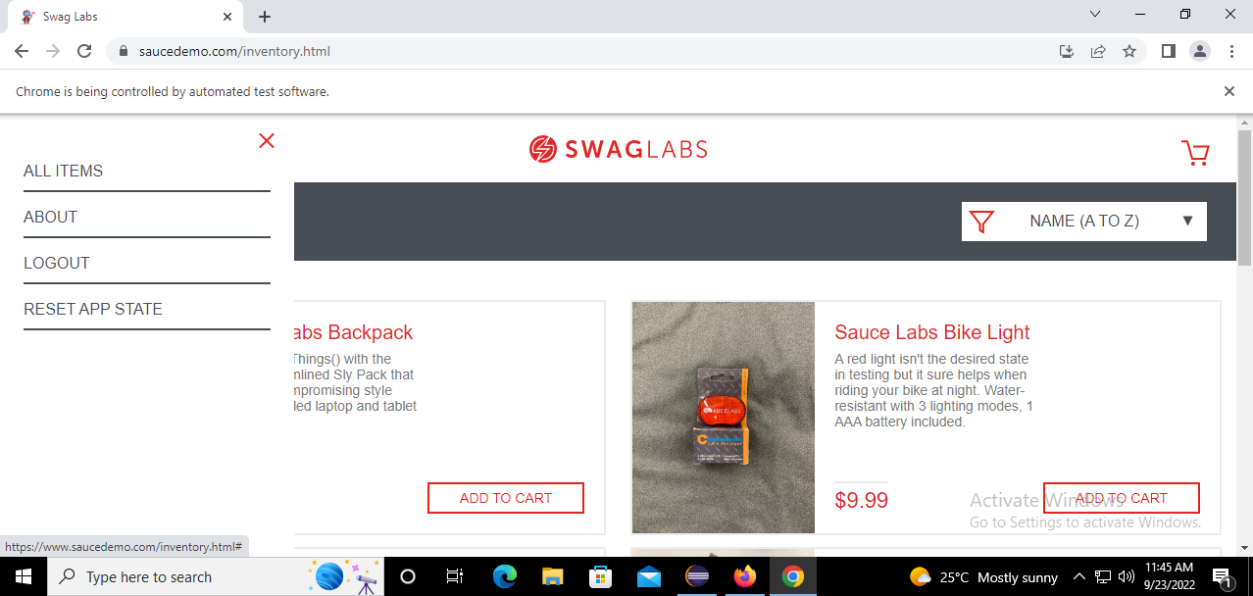

Click Logout:

driver.findElement(By.linkText("LOGOUT")).click();  
Thread.sleep(3000);  
  
Key Event:  
WebElement addproduct= driver.findElement(By.id("add-to-cart-sauce-labs-backpack"));  
Actions actions=new Actions(driver);  
*//Action mousemovement=actions.moveToElement(dropdown).click().build();*  
*//mousemovement.perform();*  
Action addtocart=actions.moveToElement(addproduct).click().build();  
addtocart.perform();  
driver.findElement(By.className("shopping-cart-link")).click();  
driver.findElement(By.id("checkout")).click();  
Thread.sleep(3000);  
WebElement fname= driver.findElement(By.id("first-name"));  
Action keyEvents= actions.moveToElement(fname).keyDown(Keys.SHIFT).sendKeys("john").keyUp(Keys.SHIFT).build();  
keyEvents.perform();  
Thread.sleep(3000);

PopUp event:

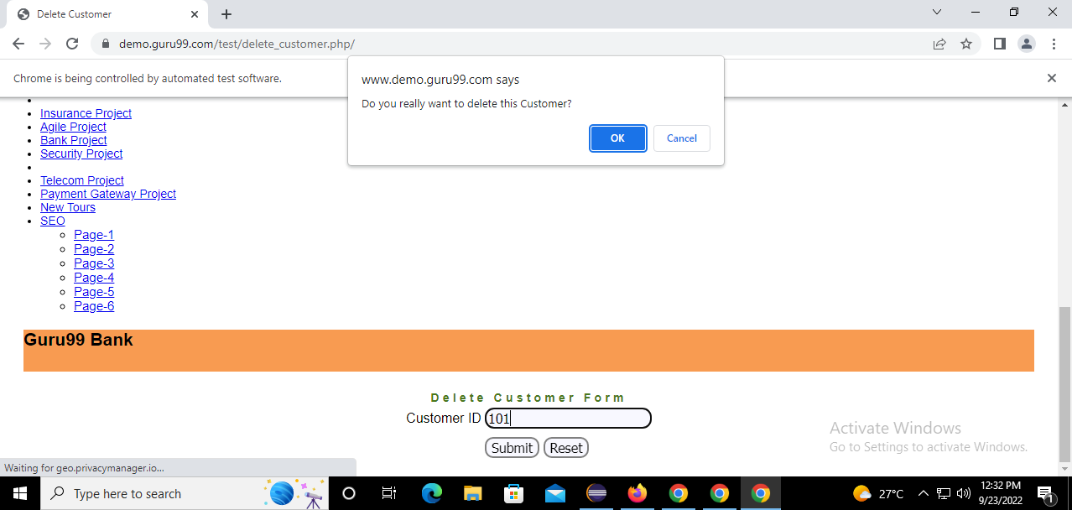

package com.demo.Automation;  
   
import org.openqa.selenium.Alert;  
import org.openqa.selenium.By;  
import org.openqa.selenium.WebDriver;  
import org.openqa.selenium.chrome.ChromeDriver;  
   
public class PopUpTest {  
   
public static void main(String[] args) throws InterruptedException {  
*// TODO Auto-generated method stub*  
System.setProperty("webdriver.chrome.driver","C:\\Users\\cgijasel44\\Desktop\\chromedriver.exe");  
*//open browser*  
WebDriver driver= new ChromeDriver();  
driver.get("https://www.demo.guru99.com/test/delete_customer.php/");  
*// typing and redirecting to given url*  
driver.manage().window().maximize();  
driver.findElement(By.name("cusid")).sendKeys("101");  
driver.findElement(By.name("submit")).submit();  
Thread.sleep(2000);  
driver.switchTo().alert().accept(); *//or .dismiss();*  
Thread.sleep(2000);  
  
  
}  
   
}  
Windows Handles:  
package com.demo.Automation;  
   
import java.util.Set;  
import java.util.concurrent.TimeUnit;  
   
import java.util.Iterator;  
   
import org.openqa.selenium.By;  
import org.openqa.selenium.WebDriver;  
import org.openqa.selenium.WebElement;  
import org.openqa.selenium.chrome.ChromeDriver;  
   
public class WindowsHandles {  
   
public static void main(String[] args) throws InterruptedException {  
*// TODO Auto-generated method stub*  
System.setProperty("webdriver.chrome.driver","C:\\Users\\cgijasel44\\Desktop\\chromedriver.exe");  
*//open browser*  
WebDriver driver= new ChromeDriver();  
driver.get("https://demoqa.com/browser-windows");  
*// typing and redirecting to given url*  
driver.manage().window().maximize();  
*//sdriver.manage().timeouts().implicitlyWait(30, TimeUnit.SECONDS);*  
driver.findElement(By.id("windowButton")).click();  
Thread.sleep(2000);  
String mainWindowHandle=driver.getWindowHandle();  
Set<String> allWindowHandles=driver.getWindowHandles();  
Iterator<String> it=allWindowHandles.iterator();  
while(it.hasNext())  
{  
String childWindow=it.next();  
if(!mainWindowHandle.equalsIgnoreCase(childWindow))  
{  
driver.switchTo().window(childWindow);  
WebElement text=driver.findElement(By.id("sampleHeading"));  
System.out.println("Text is: "+text);  
}  
  
}  
Thread.sleep(2000);  
driver.quit();  
}  
}

TestNG:

Copy and paste dependency from <https://mvnrepository.com/artifact/org.testng/testng/7.3.0> in POM.xml

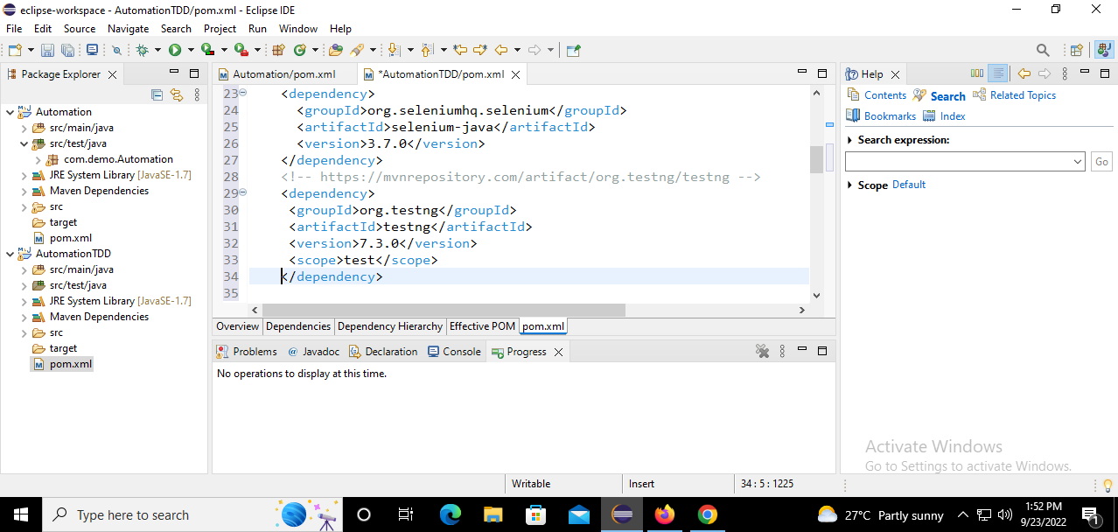

Install TestNG from Eclipse Market

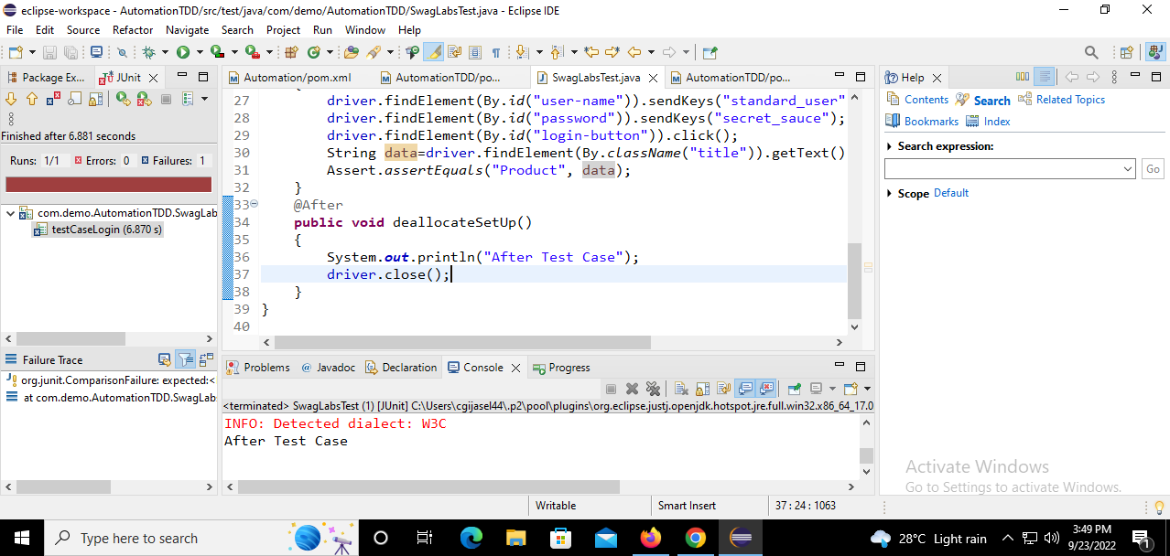

package com.demo.AutomationTDD;  
   
import java.util.concurrent.TimeUnit;  
   
import org.junit.*;  
import org.openqa.selenium.By;  
import org.openqa.selenium.WebDriver;  
import org.openqa.selenium.chrome.ChromeDriver;  
   
   
public class SwagLabsTest {  
   
WebDriver driver;  
@Before  
public void setUp()  
{  
System.setProperty("webdriver.chrome.driver","C:\\Users\\cgijasel44\\Desktop\\chromedriver.exe");  
*//open browser*  
driver= new ChromeDriver();  
driver.get("https://www.saucedemo.com/");  
driver.manage().window().maximize();  
driver.manage().timeouts().implicitlyWait(30,TimeUnit.SECONDS);  
}  
@Test  
public void testCaseLogin()  
{  
driver.findElement(By.id("user-name")).sendKeys("standard_user");  
driver.findElement(By.id("password")).sendKeys("secret_sauce");  
driver.findElement(By.id("login-button")).click();  
String data=driver.findElement(By.className("title")).getText();  
Assert.assertEquals("Product", data);  
}  
@After  
public void deallocateSetUp()  
{  
System.out.println("After Test Case");  
driver.close();  
}  
}

**DAY 5:**

**Add the below dependancy to POM.xml**

<!-- https://mvnrepository.com/artifact/com.relevantcodes/extentreports -->  
 <dependency>  
 <groupId>com.relevantcodes</groupId>  
 <artifactId>extentreports</artifactId>  
 <version>2.41.1</version>  
 </dependency>

SwagLabsTest.java

package com.demo.AutomationTDD;   
import org.openqa.selenium.By;  
 import org.openqa.selenium.WebDriver;  
 import org.openqa.selenium.chrome.ChromeDriver;  
 import com.relevantcodes.extentreports.ExtentReports;  
 import com.relevantcodes.extentreports.ExtentTest;  
 import com.relevantcodes.extentreports.LogStatus;   
import org.junit.Before;  
 import org.junit.Test;  
 import java.util.concurrent.TimeUnit;  
 import org.junit.After;  
 import org.junit.Assert;   
public class SwagLabsTest   
 {   
 WebDriver driver;  
 LoginPage login;  
 ExtentReports reports;  
 ExtentTest test;  
 @Before  
 public void setUp()  
 {   
 reports = new ExtentReports(System.getProperty("user-dir")+"ExtentReportResults.html");  
 System.setProperty("webdriver.chrome.driver", " C:\\Users\\cgijasel44\\Desktop\\chromedriver.exe");  
 driver = new ChromeDriver(); *// opening the browser*  
 driver.get("https://www.saucedemo.com/"); *// typing and redirecting to given url*  
 driver.manage().window().maximize(); *// maximize the window*  
 }   
 @Test  
 public void testCaseLogin() throws InterruptedException  
 {   
 test = reports.startTest("SwagLabsTest Login");  
 login = new LoginPage(driver);  
 login.setUserName("standard_user");  
 login.setPassword("secret_sauce");  
 login.clickLogin();  
 String data = driver.findElement(By.className("title")).getText();  
 if(data.equals("PRODUCTS"))  
 {   
 test.log(LogStatus.PASS, "Navigated to Home Page");  
 }   
 else  
 {   
 test.log(LogStatus.FAIL, "Test Case Failed. Login Failed");  
 }   
 *//Assert.assertEquals("PRODUCTS",data);*  
 }   
 @After  
 public void deallocateSetUp()  
 {   
 reports.endTest(test);  
 reports.flush();  
 driver.close();  
 }   
}

LoginPage.java

package com.demo.AutomationTDD;   
    
import org.openqa.selenium.By;   
import org.openqa.selenium.WebDriver;   
    
public class LoginPage {   
WebDriver driver;   
By username=By.id("user-name");   
By password=By.id("password");   
By loginBtn= By.id("login-button");   
   
public LoginPage(WebDriver driver)   
{   
this.driver=driver;   
}   
    
    
public void setUserName(String user)   
{   
driver.findElement(username).sendKeys(user);   
}   
    
public void setPassword(String pass)   
{   
driver.findElement(password).sendKeys(pass);   
}   
    
public void clickLogin()   
{   
driver.findElement(loginBtn).click();   
}   
}

Refer: [Selenium Webdriver Login Test Script - MySkillPoint](https://myskillpoint.com/selenium-webdriver-login-test-script-example/)

Git- Source Version Control

Jenkins – CI/CD

GitHub- Repo to upload project